Create a labeling project (preview) for multi-class image classification

* Create an Azure storage account and upload images to the account.
* Create an Azure Machine Learning workspace.
* Create a multi-class image labeling project.
* Label your data. Either you or your labelers can perform this task.
* Complete the project by reviewing and exporting the data.

I will use the same ML workspace created in previous example -> manjuML1

1. Create a datastore  
Azure Machine Learning datastores are used to store connection information, like your subscription ID and token authorization.

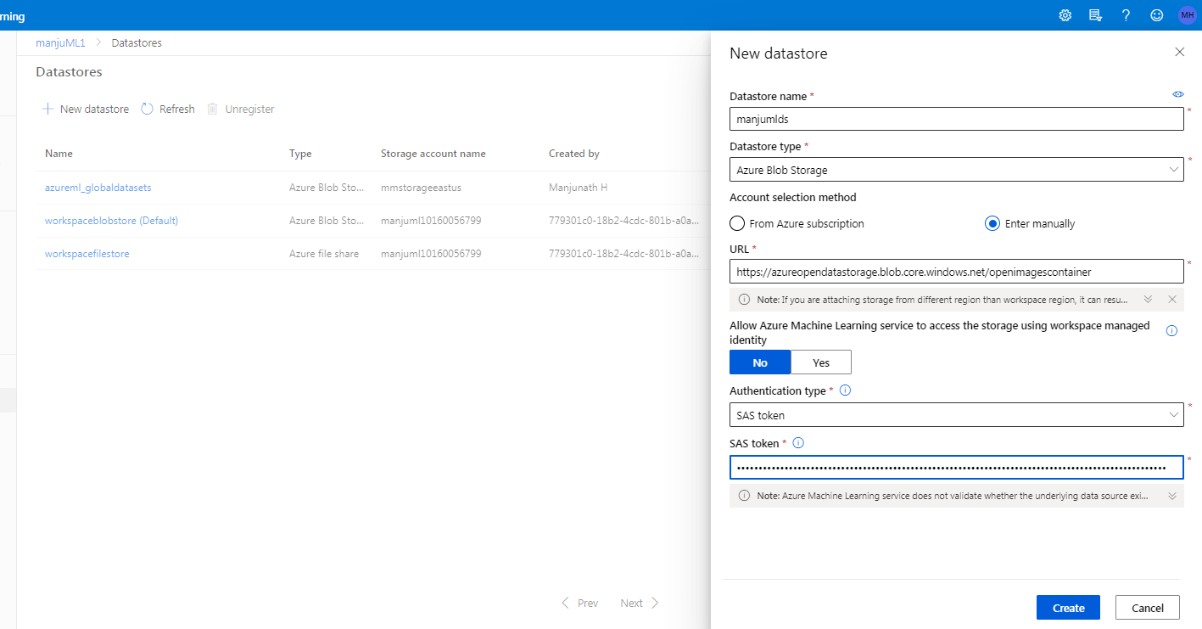

2. Create a labeling project

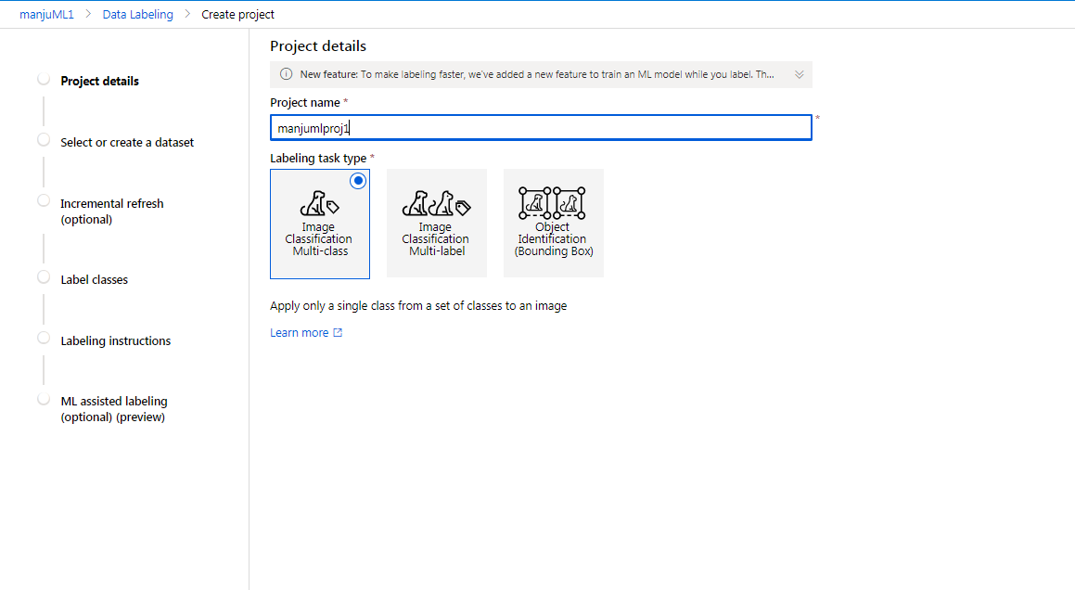

3. Incremental refresh  
If you plan to add new images to your dataset, incremental refresh will find these new images and add them to your project. When you enable this feature, the project will periodically check for new images

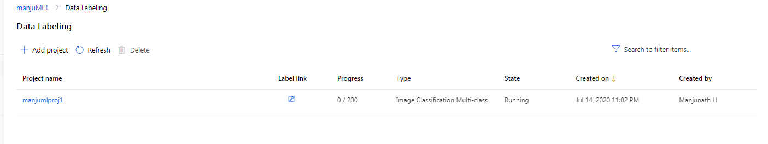

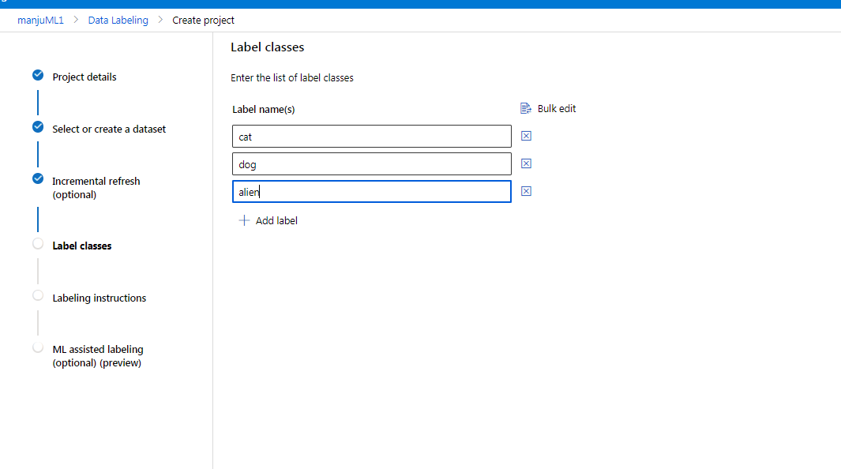

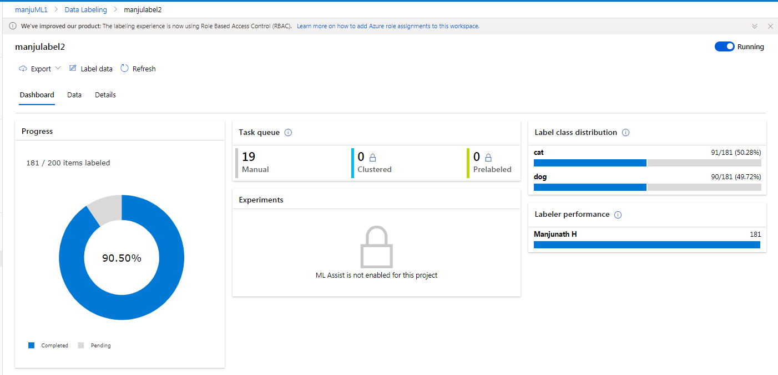

6. Export labeled data

